ETHIOPIAN CATHOLIC CHURCH
CATHOLIC SCHOOLS’ BRIEF HISTORY WITH GRADE 12th PERFORMANCE AND 2025 ANNUAL DATA

Introduction
Education is one of the most important pillar for the growth and advancement of a nation. Education is understood that due to education society as a nation and a person as an individual get a better and stable life style. Education helps an individual to think critically and make a wise and positive and fruitful decision. Moreover, education is a path to exit from the poverty and ignorance way of living desired live style.
The catholic church believes that education is one of the instrument to free individuals from poverty by realizing his or her talents that leads to financially capable, socially mature and responsible. The Catholic Church believes that through education young men and women get prepared to understand the mystery of their surroundings (environment) and appreciate and take care so that the order of nature will not be spoiled and bring challenges for human beings.
The Catholic schools enthusiastically, teach young men and women to prepare for their future life. In their life to be responsible, to have community service oriented mind through volunteerism, respecting their family, friends and knowing his or her value and praising and thanks giving for their creator, God. One of the value is standing for truth and being trustworthy before God and others.
The Catholic Schools provide moral education that centers on the principle of” Love others as you love yourself”. True love bases on realizing that human being is created in the image of God and needed to be respected and loved. No any types of abuse to be inflicted on human being and each right that is given naturally should not be taken away. Therefore, if young men and women grow with moral principles they are able to love, serve, protect and respect their neighbors and their soundings. In addition, they grow to be responsible citizens.
In general, the Catholic Schools following the curriculum and education policy that is prepared and provided by the Federal Ministry of Education. Providing both academic and moral education, the Catholic Schools prepare young men and women to be innovative, critical thinkers, problem solvers and responsible citizens. The Catholic Church works hand in hand with the sense of strong partnership with the Federal Ministry of Education.

A brief historical background of Catholic Education in Ethiopia
Catholic education in Ethiopia dates back nearly 180 years. In 1844, the first school was established in Guol’a (Adigrat), followed by a second in Alitena on September 15, 1845, both located in Irob Wereda within the Tigray Regional State. These schools were founded by Lazarist Missionaries under the leadership of Msgr. Justin de Jacobis, Prefect Apostolic of Abyssinia and its surrounding regions (Ref: Justino De Jacobis Scritti, Diario, Part Three, p. 720, 1999).
Some historical sources indicate that Portuguese missionaries introduced education in the Tigray area, specifically in a place called Fremona, and in the Gojam area of the Amhara region as early as the 16th century (Ref: Kebede Fresenbet, Forum for Social Studies, pp. 2–3, 2006 EC). Festo Mkenda, SJ, supports this historical account by stating that Jesuit missionaries established a school in the northeastern part of Ethiopia, at a site named Fremona—named after St. Frumentius (Ref: Festo Mkenda, SJ, A Splash of Diamond, Volume One, pp. 8–9, 2024).
Educational services that began in the 16th century were disrupted when the missionaries departed the country. It was not until 227 years later that formal classroom instruction resumed in 1844, as mentioned above. Other historical accounts note that by the 1800s, modern education began to spread in various forms with the arrival of more missionaries. In addition to basic literacy and numeracy, subjects such as geography, French, mathematics, and science were taught. Many scholars refer to this system as "Western education" (Ref: Hail Gabriel Dange, Studies on Education in Ethiopia: Tradition, pp. 114–115, 2007 EC).
During the first phase of Catholic evangelization in Eastern Ethiopia (1881–1938), a few schools were established. In 1882, the Brothers of St. Gabriel began an informal school in Harar, at the location of the current Abune Andreas School. By 1901, this institution had developed into a formal school. In 1896, another school was built by the Capuchin Friars in Lafto Karamile, Goro Gutu Wereda, in the Hararghe region. This school initially aimed to train young people for service in the Church.
In the history of traditional education in Ethiopia, the Ethiopian Orthodox Church has played a central role in operating traditional schools. These schools offered more than basic literacy using the Sabaean script and numeracy with Ge’ez numerals; they also included instruction in poetry, traditional music, moral education, history, philosophy, and theology.
The first modern school in Ethiopia, Menelik II School, was established in 1908 in Addis Ababa. However, 64 years before the government began promoting modern education, the Catholic Church had already taken the initiative to introduce a Western-oriented educational system in the remote northern part of the country. The school, founded in 1844 in Guol’a (Adigrat), has since been transformed into Tsinsetamariam Catholic Secondary and Preparatory School in Adigrat. This well-equipped, two-story school currently serves students in Grades 9–10 and 11–12. Another Catholic school in Alitena, called Lidetamariam Catholic School, currently serves students in Grades 7–10.
Due to historical and political challenges, the expansion of modern education did not progress as desired. In fact, the number of Catholic schools remained stagnant for nearly 70 years. It was only after Emperor Haile Selassie I came to power that the construction of Catholic schools resumed. Between 1920 and 1930, eight schools were established (see Table 1). However, the growth slowed significantly during the Italian occupation from 1936 to 1941. Between 1931 and 1951, only three schools were opened (see Table 2).
Since the early 1950s, Ethiopia has made notable progress in expanding educational access. The Catholic Church was able to contribute significantly to this expansion by constructing schools in various parts of the country. Between 1951 and 1961 alone, 19 schools were established (see Table 3), of which only four were located in Addis Ababa. The remaining 15 were built in rural and remote areas.

As the data indicates, the steady growth and expansion of Catholic Schools can be seen in relation with the coming of different ruling regimes in the country. During the Imperial regime, in particular from 1951 to 1974, in 22 years time 61 Catholic Schools were built in different parts of the country. During the Military regime from 1975 to 1991, even if there were some indications of challenges on the activities of the Church due to ideological influence and in some parts of the country some Catholic Schools were confiscated by protagonists of the ruling regime, the expansion and growth of Catholic Schools was not halted. This had been evidenced by the establishment of 77 new schools within 16 years time. During the contemporary period of the current regime, between 1992 to the present day, in 32 years time 274 schools are constructed in different parts of the country and are engaged in providing quality education (ref table 4).

Due to the existence of some favorable conditions, and the commitment of the government for education, the Catholic Church also being enthusiastic to serve the society specially in more need of her service, built more number of schools then ever. The steady growth and expansion of Catholic Schools during the various ruling regimes would be an indication of the Church’s firm stand and adherence to her mission of reaching out as much as possible to needy areas for education. It is also assisted by the existence of good and supportive relationship with the different ruling regimes.

R.N | Church Jurisdictions | School Name | Found | Wereda
1 | Adigrat | Tsinsetamariam Catholic Sec.&Preparatory School | 1844 | Adigrat
2 | Adigrat | Lidetamariam Catholic School | 1845 | Irob
3 | Harar | Karramile St. Joseph Catholic School | 1896 | Goro Gutu
4 | Harar | Harar Abune Andreas Catholic School | 1901 | Harar
5 | Meki | Waragu Catholic School | 1909 | Gololcha
6 | Harar | Dire Dawa Bisrate Gabriel Catholic School | 1910 | Dire Dawa
7 | Harar | Dire Dawa Notre Dame Catholic School | 1912 | Dire Dawa
8 | Meki | Minne Catholic School | 1920 | Gololcha
9 | Nekemte | Metcha Boroddo Catholic School | 1921 | Dandi
10 | Nekemte | Komto Catholic School | 1924 | Wayu Tuka
11 | Addis Abeba | Lazarist Catholic School | 1925 | Addis Abeba
12 | Nekemte | Sakko Medhanealem Catholic School | 1926 | Anaa Sayo
13 | Addis Abeba | St. Mary's Catholic School | 1927 | Addis Abeba
14 | Nekemte | Ghimbi St. Michael Catholic School | 1929 | Ghimbi
15 | Addis Abeba | Dessie Kidanemehret Catholic School | 1930 | Dessie Zuria

The oldest schools built between 1844 and 1930

R.N | Church Jurisdictions | School Name | Found | Wereda
1 | Harar | Dobba St. Mark Catholic Primary School | 1940 | Dobba
2 | Soddo | Dubbo Our Lady Catholic School | 1941 | Areka
3 | Hosanna | Wassera St. Teresa Catrholic School | 1944 | Doyo Gena

. Schools built from 1931 – 1951

R.N | Church  Jurisdictions | School Name | Found | Wereda
1 | Addis Abeba | St. Joseph Catholic School Adama | 1954 | Adama
2 | Hosanna | Ashira St. Anthony Catholic School | 1955 | Kacha Bira
3 | Addis Abeba | Arbaba Catholic School | 1955 | Lay Armachiho
4 | Hosanna | Taza St. Joseph Catholic School | 1955 | Durame
5 | Soddo | Mokonissa Holy Cross Catholic School | 1955 | Damot Gale
6 | Hosanna | Holy Cross Catholic School | 1956 | Duna
7 | Addis Abeba | Kidane Mehret Catholic School | 1957 | Addis Abeba
8 | Hosanna | Jajura St. Peter Catholic School | 1957 | Soro
9 | Addis Abeba | Nazareth Catholic School | 1958 | Addis Abeba
10 | Hosanna | Mudula St. Gabriel Catholic School | 1958 | Tambaro
11 | Nekemte | Filsetamariam Catholic School | 1958 | Kellem
12 | Adigrat | Medhanealem Machia Catholic School | 1959 | Irob
13 | Addis Abeba | St. Joseph Catholic School | 1960 | Addis Abeba
14 | Adigrat | Holy Trinity Catholic School | 1960 | Gulo Makeda
15 | Soddo | Fekaka St. Gabriel Catholic School | 1960 | Soddo Zuria
16 | Addis Abeba | Debre Selam St. Mary Catholic School | 1961 | Gondar
17 | Addis Abeba | Lideta Catholic Cathedral School | 1961 | Addis Abeba
18 | Nekemte | Karro Baha St. John Catholic School | 1961 | Sayo
19 | Nekemte | Addo St. Michael Catholic School | 1961 | Sayo

Schools built from 1952 – 1961

S/N | Period | Number of schools | Duration of years
1 | 1844 - 1930 | 15 | 86
2 | 1931 – 1951 | 3 | 20
3 | 1952 – 1961 | 19 | 9
4 | 1962 - 1974 | 41 | 12
5 | 1975 - 1991 | 78 | 17
6 | 1992 – to present | 288 | 33
Total |  | 444
Growth of Catholic Schools by periods

Contribution to Integral Human and National Development
The Catholic Church recognizes the critical importance of education in the life of individuals and values its influence in today’s rapidly evolving world. For the past 180 years, the Ethiopian Catholic Church has been committed to delivering high-quality educational services to the children of the nation. As a result, a significant number of individuals—many of whom have received national and international recognition for their contributions to the country’s development—are alumni of Catholic schools.
This recognition is attributed not only to the academic excellence of the schools but also to their ethical and moral formation, with reverence for God at the core of their values-based education.

Delivery of Holistic Education
Education today is a complex task, made more challenging by rapid social, economic, and cultural changes. Nevertheless, its fundamental mission remains the integral development of the human person. Catholic schools are dedicated to providing holistic education that fosters both academic competence and spiritual maturity, playing a vital role in the education and formation of children.
These schools aim to cultivate an environment where both secular and moral education are impactful. Within this environment, cultural values, respect for oneself and others, human dignity, and human rights are taught and embodied. Catholic schools foster respectful and familial interactions within the school community, helping students develop socially and culturally commendable behavior. Such characteristics have drawn the attention and appreciation of both parents and government bodies.
Through continued dialogue with the Federal Ministry of Education and other key stakeholders, the Catholic Church has contributed to the introduction of moral education as a subject. This curriculum is currently being implemented at the pre-primary and primary levels. The Church welcomes this development and advocates for the inclusion of moral education at the junior-secondary and high school levels as well.

Delivery of Quality Education and Parental Choice
Catholic schools are dedicated to providing quality education that equips students for academic success and life’s challenges. In many Catholic schools, students consistently achieve high scores in both regional and national examinations. Moreover, graduates of these schools often excel in institutions of higher learning.
These achievements are driven by a strong spirit of dedication within the school community, where teachers and staff invest their energy, knowledge, and skills in shaping students. This level of commitment distinguishes Catholic schools from their non-Catholic counterparts, making them a preferred choice for many parents.
In addition to academic excellence, Catholic schools place strong emphasis on discipline and moral education. Moral instruction is a core component of their educational mission, aiming to integrate ethical values with secular knowledge in the holistic development of each student.
Recognizing the challenges of modern education, Catholic schools encourage collaboration with parents and other partners to fulfill the Church’s mission. The Church firmly insists that moral education remain a foundational component of Catholic schooling. Importantly, this instruction is not about teaching Catholic doctrine but rather focuses on universal Gospel values, applicable to all children regardless of religious background. These values aim to enlighten students’ minds, center their lives on their Creator, and foster love and respect for others.
This approach cultivates a school community characterized by compassion, service, and faith, where interpersonal relationships are guided by care and mutual respect.
Whether located in urban or rural areas, Catholic school facilities are well-maintained and classrooms are properly equipped to support effective teaching and learning. Cleanliness, orderliness, and discipline are hallmarks of Catholic education, and many parents are drawn to these schools for precisely these reasons. Discipline is seen as integral to a child’s overall development. When a child demonstrates good behavior within the family and broader community, it reflects the values instilled by their school.
Consequently, Catholic schools are widely appreciated and increasingly sought after by parents. For example, the following tables and graphs depict the result of the Catholic schools grade 12 for the last three years.

Total number of students who sat for exam |  |  | Scored 50%& above |  | Scored 50%& above
stream | 2014 | 2015 | 2014 | % | 2015 | %
Natural Science | 339642 | 356878 | 22974 | 6.8 | 19017 | 5.3
Social Science | 556878 | 488221 | 7060 | 1.3 | 8250 | 1.7
Total | 896520 | 845099 | 30034 | 3.3 | 27267 | 3.2
The results of Grade 12 as National for two years 2014/2015 E.C based on Streams.

Total number of students who sat for exam |  |  | Scored 50%& above |  | Scored 50%& above
Gender | 2014 | 2015 | 2014 | % | 2015 | %
Male | 485393 | 447567 | 20438 | 4.2 | 18383 | 4.1
Female | 411127 | 397532 | 9596 | 2.3 | 8884 | 2.2
Total | 896520 | 845099 | 30034 | 3.3 | 27267 | 3.2
The results of Grade 12 as National for two years 2014/2015 E.C. based on Gender

Total number of students who sat for exam |  |  |  | Scored 50%& above
stream | 2014 | 2015 | 2016 | 2014 | % | 2015 | % | 2016 | %
Natural Science | 3499 | 3628 | 4256 | 1549 | 44.3 | 1806 | 49.8 | 2350 | 55
Social Science | 1076 | 1425 | 1808 | 326 | 30.3 | 503 | 35.2 | 981 | 54
Total | 4575 | 5053 | 6064 | 1875 | 41 | 2309 | 46 | 3331 | 55
The results of Grade 12 as Catholic School for three years 2014-2016 E.C based on Streams.

The above graph shows the total number of students in the Catholic Schools took the national exam and the number of students who qualified to join government universities in the last three years period of time from 2014 to 2016 E.C.

Academic Years | 2014-2016E.C.
Male | 7233
Female | 8459
Total | 15692

The above graph and the table depict the total number of students who sat for the national exam at Catholic Schools in the country

Academic Years | 2014-2016E.C.
Male | 3669
Female | 3846
Total | 7515

Academic year
Gender | 2014 | 2015 | 2016
Male | 2355 | 2228 | 2650
Female | 2220 | 2825 | 3414
Total | 4575 | 5053 | 6064
Total number of students who sat for national exam by gender

Total number of students who sat for exam and
Scored 50%& above by gender
Year | 2014 | % | 2015 | % | 2016 | %
Male | 1002 | 53.44 | 1106 | 49.6 | 1561 | 58.9
Female | 873 | 46.56 | 1203 | 43 | 1770 | 51.8
Total | 1875 | 41 | 2309 | 46 | 3331 | 55

Comparing the gender performance, the female group has shown improvement in each year and also surpassing the male group. However, in both gender it can be observed that there is an improvement of performance in each year.

Number of students who qualified for Remedial program
Year | 2014 | 2015 | 2016
Male | 463 | 586 | 608
Female | 410 | 1088 | 1008
Total | 873 | 1674 | 1616

Those who get the point for remedial program as the result shows, score to join universities after they attend the remedial program. So all those who were qualified for remedial program in the past three years(2014-2016 E.C.) have joined the government universities.

The following success stories are a proof for the quality education services that the Catholic Schools provide.
Lideta Catholic Cathedral School
There are 36 Catholic High Schools in different parts of the country. These schools since they are established they have been preparing individuals for their considerable contribution in the country as well as in the international development and advancement of technology, medicine, space exploration, politics, economics and the rest of activities.
Just to mention the recent success of Lideta Catholic Cathedral School’s contribution the following photo below presented. These medical school of Addis Ababa graduates of 2024 are 42 and all of them are from Lideta Catholic Cathedral School. Still there are more graduates from other universities.
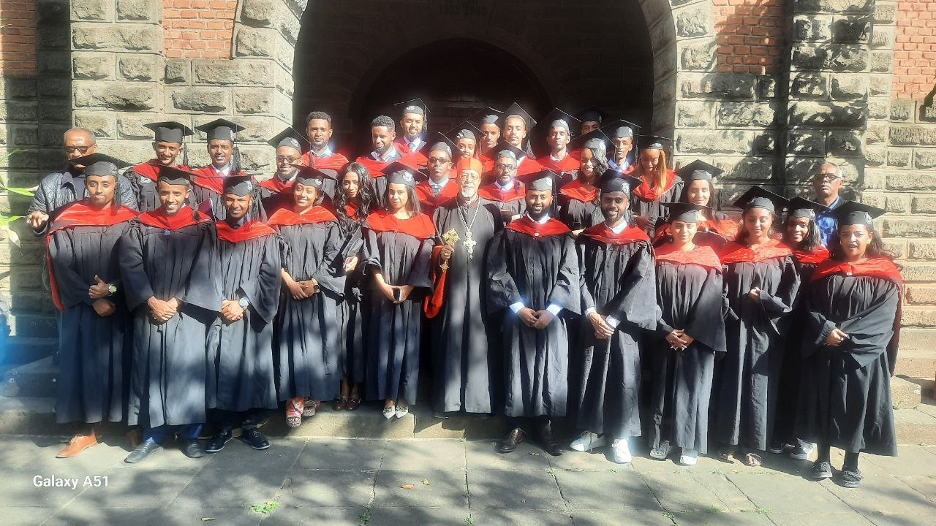
These graduates came to their school to express their gratitude to God as well as to school administration and the whole staffs.
The Catholic Schools will continue being and strengthening the partnership with the Federal Ministry of Education and the whole part of education offices in all Regions to build a better and fruitful generation.

St. Joseph Catholic School of Addis Ababa
Clearly, Catholic Schools have produced citizens that have always been part and parcel of the Nation’s socio-economic growth. And St. Joseph Catholic School is one of the leading educational institutions in availing great brains both to the country and well beyond. Moreover, because of its academic excellence, St Joseph is well always recognized, both by the Education Ministry and Addis Ababa City Mayor.
In 2015 E.C alone, St. Joseph Catholic School was named as the second best private School in Addis Ababa. Incidentally, the highest mark in the history of the Ethiopian Secondary School Leaving Certificate Examinations (669/700) which is still the record, is being held by a St. Joseph School student.
Over and above its academic reputations, St. Joseph Catholic School is well recognized for its extracurricular activities. Subsequently, Drama, Music, Sports, Charity Activities are given strong emphasis. As a matter of fact, our students spearhead the various charity activities by raising money and collecting stationaries in order to assist students in other public schools on a yearly basis.
Having acquired the various virtues while students at St. Joseph, our former students also give back to their Alma Mater. They cover the school fees of academically witty but financially needy public school students who are interested to join St. Joseph School through a scholarship program. For all the above reasons and many others, the Catholic Schools continue to leave indelible marks in the whole country.
Axiilum Catholic School
A graduate of grade 12 from the Axilium Catholic School Addis Ababa, Bole Bulibulla passed her message to her colleagues and school staff. Her name is Sifene Teklu who was the top scorer of grade 12 national exam of 2016E.C. She scored 575/600 from the Natural Science section. Her message is as follows;
Auxilium Catholic School-Salesian Sisters of Don Bosco
Good morning, esteemed faculty, proud parents, and excited siblings who are here to celebrate us, and, most importantly, my fellow graduates. Today, we wrap up our high school experience and officially declare our passing to the next level of challenges life throws at us. Friends, buckle up, and cheers!
Our batch, Zeteharyu (which by the way means the chosen ones), has been unique in so many different ways: 16 of us have been together since kindergarten; many of us endured through elementary school together, nailed Ministry with absolutely no-fail, and above all, made it through high school hand-in-hand. Now, however, we are parting ways. But since perfect love casts out all fear, there really is no fear within us. Sure, it might not have clicked yet, but we have made many bonds to further strengthen, skills to nurture, and, in the process, memories to cherish. May we always remember that, regardless of the unpredictability of life, we do have God with us. He who brought us this far will sustain us till the end. And when things do not make sense (which happens more often than not), may we rest in His character. Zeteharyu, our batch, gives all the credit for every single one of our successes and the due glory to Him! For real, what would have happened otherwise? The answer belongs to the conscience.
Now, to our teachers and everyone who tried their best to help us see this moment, thank you. Thank you, to the students who always saw the best in others and encouraged them. Thank you, to our principal, Mr. Zenebe, and our vice principal, Mr. Tekalgn, for all the energy you have invested in us. Thank you, to the sisters who always had our backs and strived to make the learning environment as conducive as possible. We extend our deepest gratitude to everyone who worked for our collective good, whether openly or behind the scenes. We are the cumulative sum of your investments.
In conclusion, here is a message from me to you: remember your goal. Through the ups and downs, the emotional roller coasters, and the moments that test your integrity, never give in. As you have probably
heard awfully many times, “What goes around, comes around,” or, in even better words, garbage in, garbage out. Never expect to get what you haven’t worked for; that will end in disappointment. If you manage to secure it illegitimately, well, that will start a chain reaction of illegitimate acts. Then what? Yeah, it fires back. Therefore, remember your goal. Keep your eyes on who you want to be. And that individual, the future you, should be above reproach and respectable by all. I have no doubt: every single one of us here is capable!
So here’s to us, the Class of 2024. We came in right through those doors, got equipped, and moments later, we will be leaving out, to make our dreams come true and to work on our goals. It is indeed my strong hope that we will have a reunion some few decades later and celebrate together once again. We truly were chosen for such a journey, and behold, we absolutely did it. Congratulations, everybody!

The following is the Catholic schools’ data for the year of 2017/2024-2025.

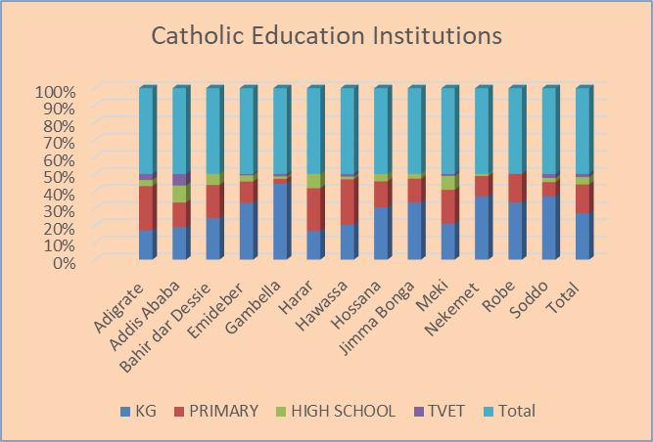

The above table and graph show the Catholic Church Education Institutions. The institutions are treated as Kindergarten, Primary, High School and Technical Vocational Training Institutions.

Name | No of Students
 | Male | Female | Total
Adigrate | 9040 | 9343 | 18383
Addis Ababa | 16882 | 20110 | 36992
Bahir dar Dessie | 6845 | 7347 | 14192
Emideber | 5587 | 5711 | 11298
Gambella | 2191 | 2149 | 4340
Harar | 5115 | 4892 | 10007
Hawassa | 12664 | 12339 | 25003
Hossana | 9123 | 9094 | 18217
Jimma Bonga | 2413 | 2584 | 4997
Meki | 12536 | 12434 | 24970
Nekemet | 5457 | 5115 | 10572
Robe | 3395 | 3169 | 6564
Soddo | 4498 | 4871 | 9369
Total | 95746 | 99158 | 194904

The table and graph show the number of students in each Diocese. The female participation also more than that the male students.

Name | No of Teachers
 | Male | Female | Total
Adigrate | 309 | 303 | 612
Addis Ababa | 762 | 716 | 1478
Bahir dar Dessie | 302 | 228 | 530
Emideber | 202 | 223 | 425
Gambella | 61 | 67 | 128
Harar | 190 | 164 | 354
Hawassa | 451 | 290 | 741
Hossana | 296 | 196 | 492
Jimma Bonga | 74 | 137 | 211
Meki | 354 | 342 | 696
Nekemet | 169 | 90 | 259
Robe | 78 | 76 | 154
Soddo | 192 | 181 | 373
Total | 3440 | 3013 | 6453

The above table and graph show the number of teaching staff in each Dioceses and the total number of teaching staff in the Catholic schools.

 | Name | Administration
 |  | Male | Female | Total
1 | Adigrate | 190 | 212 | 402
2 | Addis Ababa | 318 | 522 | 840
3 | Bahir dar Dessie | 155 | 140 | 295
4 | Emideber | 103 | 93 | 196
5 | Gambella | 33 | 10 | 43
6 | Harar | 70 | 95 | 165
7 | Hawassa | 187 | 124 | 311
8 | Hossana | 106 | 79 | 185
9 | Jimma Bonga | 69 | 91 | 160
10 | Meki | 154 | 163 | 317
11 | Nekemet | 81 | 80 | 161
12 | Robe | 44 | 34 | 78
13 | Soddo | 58 | 30 | 88
 | Total | 1568 | 1673 | 3241

The above table and graph show the number of non-teaching staff in each Diocese as well as in the Catholic Schools throughout all Dioceses

Name | By Diocese | Cong | Church and Gov | Handed over to the government | total
Adigrate | 20 | 27 | 6 | 0 | 53
Addis Ababa | 4 | 39 | 1 | 1 | 44
Bahir dar Dessie | 2 | 19 | 0 | 0 | 21
Emideber | 24 | 14 | 1 | 0 | 39
Gambella | 28 | 7 | 0 | 0 | 35
Harar | 6 | 4 | 3 | 0 | 13
Hawassa | 27 | 28 | 1 | 0 | 56
Hossana | 22 | 11 | 1 | 0 | 34
Jimma Bonga | 4 | 8 | 0 | 0 | 12
Meki | 24 | 19 | 0 | 0 | 43
Nekemet | 14 | 18 | 3 | 2 | 35
Robe | 15 | 4 | 0 | 2 | 19
Soddo | 21 | 19 | 0 | 0 | 40
Total | 211 | 217 | 16 | 5 | 444
The table show that schools run by which body. For example, there are 211 schools run by the Dioceses while 217 schools are run by Religious Congregations. There are also 16 schools which run by the Church or Diocese and the government. This means the government either provides teachers and student’s’ text books or pays salary for teachers while the Church takes part of administration and owning the prosperity. There are five schools which are already handed over to the government due to financial challenges. The following table shows the distribution of catholic schools by region.

Region | No of Schools
Tigray | 53
Addis Ababa | 28
Oromia | 135
Amhara | 16
CE | 71
Gambella | 30
Dire Dawa | 4
Harari | 2
Afar | 4
Sidama | 31
SE | 52
SWR | 9
Somalia | 1
Benishangul | 8
Total | 444

As the above table and graph indicate that almost the catholic schools are found in each regions even though the quantity may differ. For example, there is only one school in Somalia region while 135 schools are found in the Oromia region.

